Association of Revolutionary Turners

June 2008 Newsletter

Meeting Minutes

Meeting called to order at 7:06pm. About 19 members in attendance. President reminded all members that we are a chapter of A.A.W. and that if you are interested in becoming a member yourself he has fliers on the subject.

Calendar events: Marshfield and Topsfield fair are fast approaching and we would greatly appreciate you signing up to volunteer early. Dates are as follows Marshfield Aug.14th thru the 24th. Dave Eaton is the person in charge of this event. Please feel free to ask Dave all about it. Topsfield is Oct.2nd thru the 13th Mike Souter is in charge of this event feel free to ask Mike anything. The Spirit of Wood Show will be held Oct. 19th at M.C.C. in Bedford. Dicky Vose will get more details for us.

Open Turning Day: We will be having Open Turning Day on August 9th at M.C.C. in Bedford. We hope to have a Silent Auction and large Wood Swap. So if you have any spare wood lying around that you would like to get rid of, donate it to our cause. Same with the Silent Auction. As our past president has said it’s a good time to clean out the wood shop and help a good cause at the same time. The open turning day is in lieu of our regular meeting.

Picnic: We will be having a club picnic this year. It will be on Saturday July 26th rain date the 27th at our president’s home in Billerica. This is in lieu of our regular meeting. The pres. will provide burgers and dogs, and you are asked to bring a side dish. We did talk about what kind of theme this event could be such as bowling, Frisbee, rocket launcher, lawn darts. More details on this event will be sent out in an email with directions to Isaac’s House.

Gary Bashian has supplies for sale. Dick Vose stated that we now have 54 members paid for this year. To all, membership is due. No response to our renowned turner, due to the fact that the vice president was at the national symposium and not with us.

Mike Souter needs pictures for the flyer. Talk went back in forth on how we are going to use these flyers. Do we want them at the fair? Depending on the cost or do we want to just use business cards? We will come back to this issue when we know cost of flyers.

Dick Vose has wood to unload in his car.

Break 8:00pm. Return with Show and tell:

Jerry Joaquim Made a natural edge Birch burl bowl with bark inclusion through-out the bowl. Because of all the bark he left it on the heavy side for fear of losing it completely. Good job Jerry. He is using a tung oil finish. Jerry also made a tear drop clock out of olive wood.

Charley Kavenaugh spent a Saturday with mentor Steve Resnek and made his very first bowl. Charley couldn’t thank Steve enough for sharing his Saturday and his knowledge with him. Just to let everyone know, we have a mentor list on the website. All it takes is a phone call for some free help. Charley’s bowl was outstanding with a great bottom on it.

John Santoro had the mate to Ron’s oak bowl. If you remember from May’s meeting he was asked to take the other half of the log that Ron had made a bowl out of and make a second bowl. He did it. And it looked great. When these bowls are completely done they will be donated to the wheelchair project. Charley and Jerry have taken the bowls for the next phase. I wonder what that will be.

Mike Green has his bowl bottom donkers with him this evening. All proceeds from the sales go to the club. He also had with him the new “Grenco” products that he fabricated for Donna’s barn Raising.
1) A drill bushing jig with built in clamp, to drill at 45 degrees in barn braces.
2) A modified 9/16” auger bit with modified extension.
3) A piloted counterbore partly made from an oddball hardened left handed
woodturning spur drive.

Donna Banfield did a critique on herself. Donna had 2 cherry bowls that she made about 6 months apart. The only difference in the two was the bottom of the bowls. One ended straight down to the table and the other had a slight roundness near the bottom which was much more pleasing to the eye. It goes to show that with a little bit of time and patience things get better as you go along.

8:35pm meeting turned over to Donna Banfield and her demo on weed pots. Special thanks to Gary Bashian for being our club reporter this evening.

Meeting adjourned at 10:00pm

ART Demo 6-19-2008
Donna Banfield
How to Turn a Weed Pot

A weed pot is a small, simple vase for a dry or real flower. This is a great beginner project.

Mount the block between centers. Donna likes the spring-loaded Stebcenters.

After a brief delay to retrieve the toolrest from Isaac Burk's (Dad-to-be) car ...

Donna turns the block to round with a 1 ¾" Spindle Roughing Gouge. This is a spindle tool only, it should not be used on bowls. Turn a tenon on one end to fit in a chuck. This should be the larger end, if they're of different diameters. Tenon should be flat on end, straight or dovetailed on side.

Mount blank in chuck. But sure that tenon does not bottom in jaws and shoulders of block rest on top of jaws. Donna likes Vicmarc chucks, as the slides (knuckle-busters on some chucks) do not protrude, and the jaws are straight and smooth.

Mount a ½" bradpoint bit in the tailstock. Depending on the length of the piece, drill as far in as possible. The bradpoint bit clears chips more easily than a Forstner bit.

Bring up tailstock. Establish overall shape with spindle gouge.

Remove tailstock. Form top of weed pot. Take light cuts, as you're cutting far off the headstock and the piece is unsupported, held only in the chuck. Donna likes the detail gouge profile on her spindle gouges. Be sure to ride the bevel for a better and safer cut.

Replace tailstock as soon as top is complete. Use cone center or soft material to protect wood.

Refine the outer shape. Start at tailstock end and move left, or at center and move to both ends for longer pieces. The mass is needed to reduce vibration. Donna reduced the top diameter from the original to maintain proportion. Remember to cut downhill. Donna made a bead at the neck. Check wall thickness at neck.

Donna uses the parting tool to mark the point at which to start the taper to the base. Complete final shape. Donna suggests closing your eyes to detect bad spots with your hands. Measure depth of hole, be sure there is sufficient wood at bottom, below tube.

Sand and finish. Part off with parting tool or skew.

For the inner tube, Donna uses clear plastic tubing sealed with hot-melt glue. Though it takes a bit longer, she prefers this over the glass tubes, which can fall out and break. The curved plastic tube stays in better. Cut tube with sharp knife. Put bead of glue on inner lip and bottom, set on skew or other flat surface to seal.

For production work, Donna suggests doing various operations in batches to save time.

An option is to leave some bark on the outside, strengthen with CA glue.

Because of the poor economy, turners need to offer less expensive items like this at craft fairs. Try to have an odd number of items in each group, as this makes a more balanced and pleasing display.

Thanks, Donna.

Ed Note: The following demo summary by Andy Osborne is from the recent AAW National Symposium in Richmond, VA. Thanks, Andy

Star Segment Insert Goblet - Eli Avisera
A review by Andy Osborne

Attendance at the AAW Annual Symposium is exciting. We get to rub elbows with stars from all about this world in our corner of the woodturning universe. While not the overloaded feeling I had with my first symposium in Providence, I am happy to say that every rotation in Richmond was a learning experience. Even the least desirable, in my view, provided a tidbit or two of information which will be useful.

Given my reserved character, I thought it appropriate to begin the first rotation with what I believe to be an extremely difficult technique to master. Eli Avisera from Israel is well known for his carefully crafted inserts. A close examination of his pieces yields nary a hint of poor craftsmanship. The patience and precision exhibited are something we can each strive for regardless of the piece being worked upon.

Begin with a block of high quality dense wood 1” sq. x 16” long to make the star (Ebony was used in the demo). The dimensions can be altered to fit your plans. Be sure your corners are all 90 degrees. Using a straight router bit, remove the four corners as shown in the diagram.

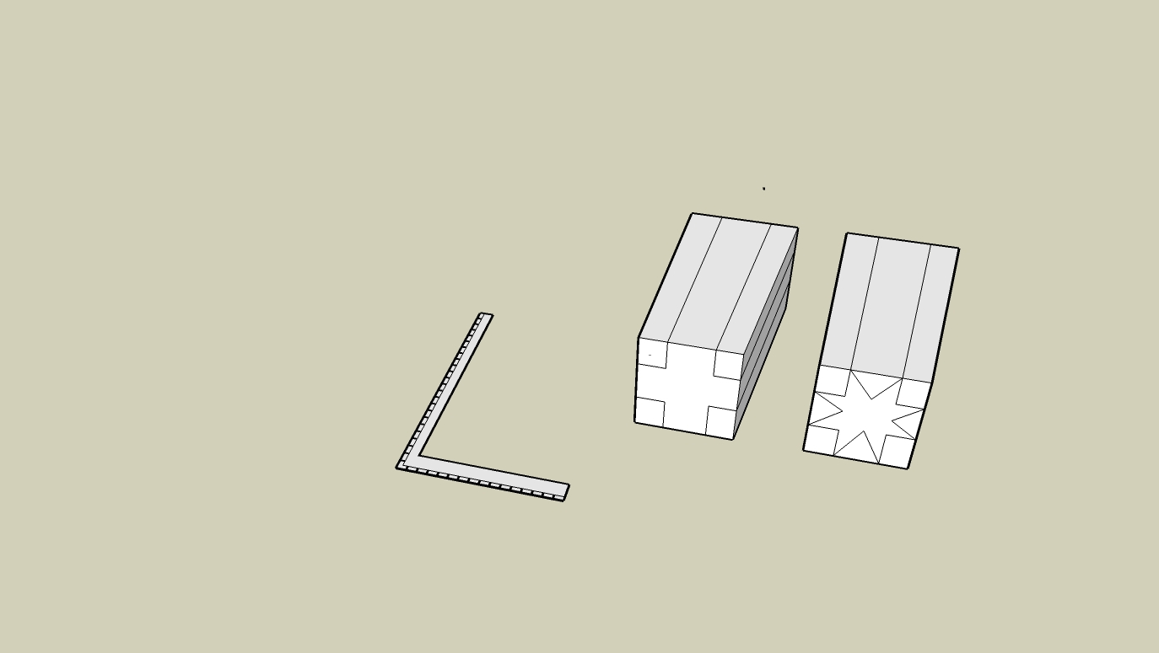
The area removed at each corner represents 24 to 30 % of the total height and width of the block. Adjust the ratios as needed. Glue (tite-bond original or #2) strips of contrasting wood (maple was used) 1 mm larger in each dimension than the area routed out. Trim off the excess on the table saw. Your block should once again have exact 90 degree corners. Using a 90 degree cutter in the router, remove the central section of each side to the exact depth of the corners to create the star shape. The same (or different if you so desire) wood as was used to fill the corners is now glued into the newly cut angles two adjacent sides at a time. This is done to maintain a pair of flat surfaces for trimming the glued pieces on the table saw. Go ahead and trim. Repeat with the remaining pair.

The next design feature involves veneer sandwiches on the four sides. You decide the wood and number of layers. For the demonstration, the package was two layers of ebony and two of maple. Glue the sandwiches on opposite sides in pairs, using a block to spread the clamping pressure. Trim the edges then glue on the remaining pair of sandwiches.
Trim to recreate your block with 90 degree corners. You can now add additional blocks on all side, working in pairs as above.

What about the lathe, you may ask. After all, turning is part of the advertised theme. Now to it. Mount your newly finished (oops, do allow the glue to dry) block at the centers. The length of the block should be slightly longer than the final size of your project. If you are not exact, the stars in your universe will be off-center. Round the block to a cylinder and create a tenon on one end for the chuck. You may at this stage want to part the cylinder into several pieces, each
corresponding in length to either a goblet base or cup. If you do, make provision for tenons as needed.

Start on the base. Mount the 2-3” cylinder in the chuck. Create a small recess for the chuck jaws on the end, then turn this entire face slightly concave, scrape, sand and finish. He uses Rennaisance Wax. Before sanding, seal the surface with sanding sealer to prevent the ebony or other dark color from bleeding into the lighter wood. You now need a tenon on this end which has a smaller diameter than that first used. The base will be smaller than the cup.

Install the 3-5” cylinder for the cup in the chuck. Rough shape the outside of the goblet cup leaving plenty of mass at the base and along the stem. Hollow the inside of the cup using care to avoid tear out. Torn grain cannot be easily sanded away and cutting may alter the shape of the goblet. Coat with sanding sealer before sanding to prevent color bleeding. Drill through the cup with a self-centering bit the same diameter (5 mm perhaps) as the tenon on the stem that you will separately make. Bring up the tailstock with a large cone center to provide stability to the cup as you finish the outside and add the desired detail around the area where the stem will be inserted. Part off. Create jam chuck with piece remaining in chuck and reverse cup to complete bottom. Apply finish.

Remount base onto recess using spigot jaws. Use tail stock as needed for stability. Turn to desired shape, drill same size hole as in cup and apply finish.

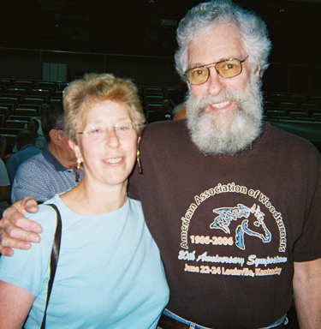
To create a stem, turn the desired stock to 3/8” diameter. Size a tenon on each end to fit the holes drilled in the cup and base. Avisera uses a metal sizing tub which also fits into the tailstock to center the stem. A 3/8” diameter piece will fit through the headstock and can be withdrawn 1’ at a time through the collet chuck. Completely finish each section before moving on to the next. Create a string steady to fit on the tail stock consisting of a round block (3” diameter) into which four nails are evenly spaced around the diameter. Use thread, waxed line, or other desired material crossed over stem to provide support. The process is much like that used with a trombleur.

ART member Bobbi Tornheim with renowned woodturner David Ellsworth at Richmond

